2026-CMP_SC-8540 - BIG DATA AND MODEL MANAGEMENT
PHASE 2

AI TRUST PARADOX - An Empirical Study of Trust in AI Coding Tools
Preya Patel, Sai Srikar Reddy Kolli

Introduction

Do developers trust AI more as they use it more or does deeper usage expose limitations and reduce trust? This project investigates this AI Trust Paradox using the 2025 Stack Overflow Developer Survey. We built a five-stage Spark and Ray pipeline that creates composite scores for AI usage, trust and frustration, segments developers into trust-usage quadrants and applies machine learning to predict paradox group membership and serves an interactive Panel + Bokeh dashboard for exploration.

Dataset

The primary dataset is the 2025 Stack Overflow Developer Survey (CSV, Open Database License) (https://survey.stackoverflow.co/.). It is an anonymous online survey distributed by Stack Overflow to its global developer community. Respondents answered questions across 5 sections which are Learning and Career, Tech and Tech Culture, Community, AI and Final Thoughts. The full survey PDF is attached here - (https://drive.google.com/file/d/1PR6mqITdGSE1DOPNoESzZRbxO4n-Ey72/view?usp=sharing)

System Architecture

Our pipeline has five stages. First, we load the raw CSV into Spark and clean it - selecting columns, removing duplicates and handling missing values. Second, we engineer three composite scores (Usage, Trust, Frustration) from multiple survey columns. Third, we run seven Spark SQL queries to find patterns. Fourth, we use Ray to run K-Means clustering and Random Forest classification in parallel. Finally, we generate nine visualizations, run automated tests, and serve an interactive dashboard using Panel and Plotly.

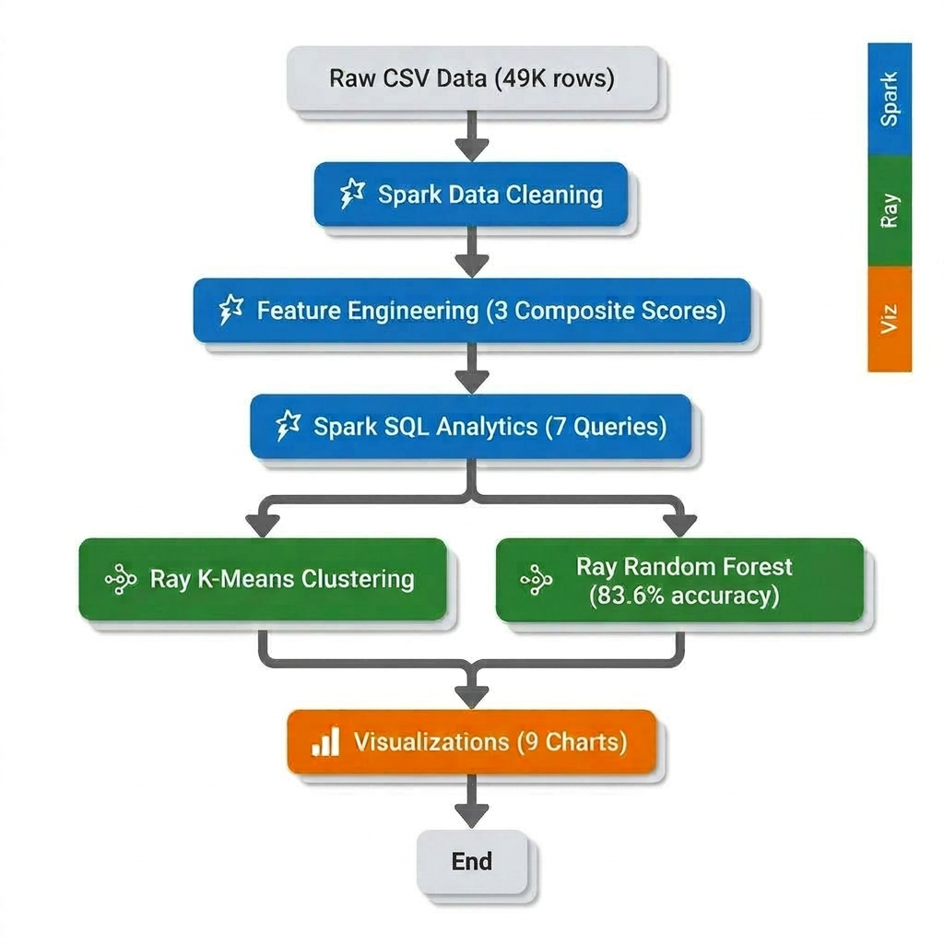

Feature Engineering

Each score combines multiple survey columns, normalized to 0-1 before averaging and scaled to 0-100.

- Usage Score: Captures how actively developers engage with AI tools across different dimensions. It incorporates usage frequency, depth of AI agent interaction, diversity of AI models used (capped at 10) and the extent of workflow integration.

- Trust Score: Measures developers confidence in AI systems by combining perceptions of output accuracy, ability to handle complex tasks, and overall sentiment toward AI tools.

- Frustration Score: Quantifies negative experiences with AI by combining the number of issues encountered (capped at 5 to limit outliers) and perceived job threat (mapped to a continuous scale). This captures both practical friction during usage and broader concerns about AI’s impact on developers’ roles.
Spark SQL Analytics
We added the dataset as a Spark SQL table and ran seven queries to find patterns in how developers use and trust AI tools. The first thing we noticed is that AI adoption is strong - 15,883 developers (32%) use AI tools daily and on the other end 5,454 developers said they have no plans to use AI at all. We then grouped developers into four usage bands based on their composite Usage Score and looked at how trust and frustration change across them and found out heavy users trust AI more, but they also run into significantly more problems.
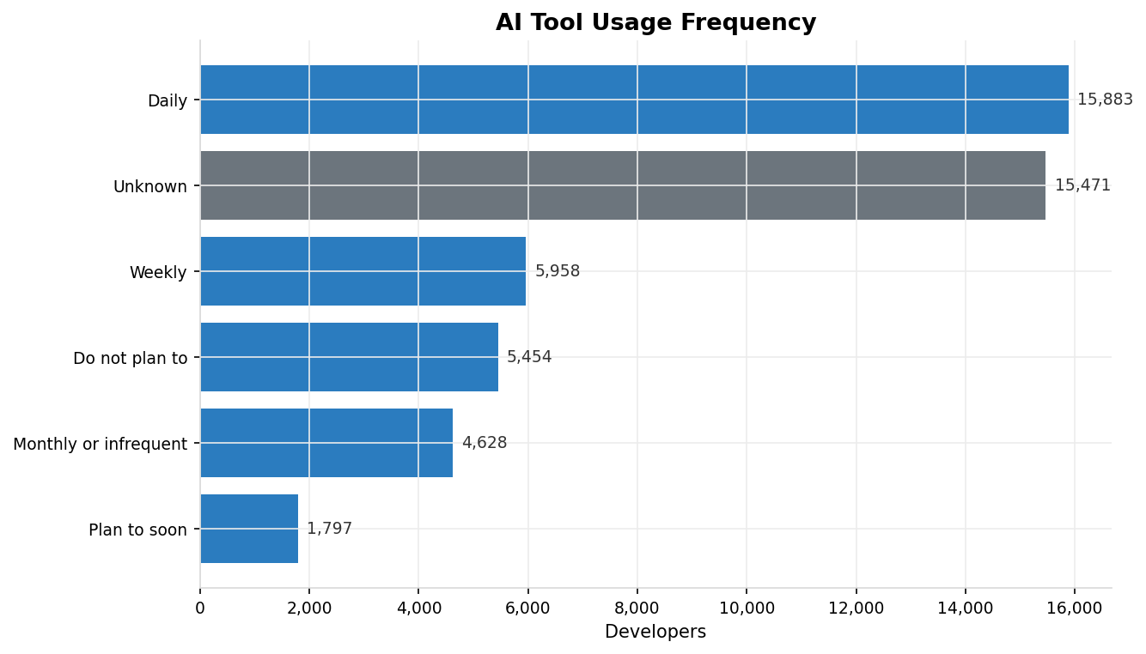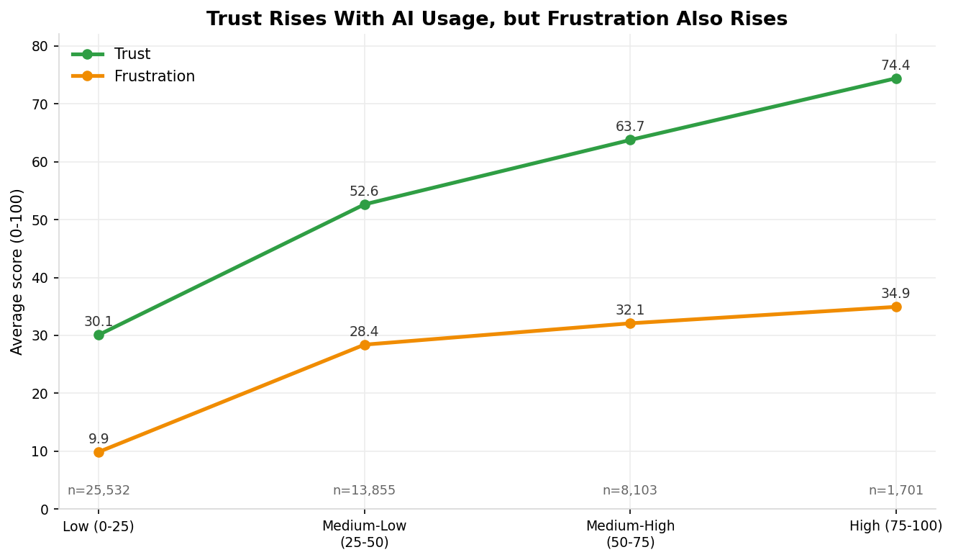
We also looked at trust by developer role. AI app developers lead with the highest average trust and game/graphics developers and embedded developers report the lowest trust and interestingly, trust barely changes across experience levels.
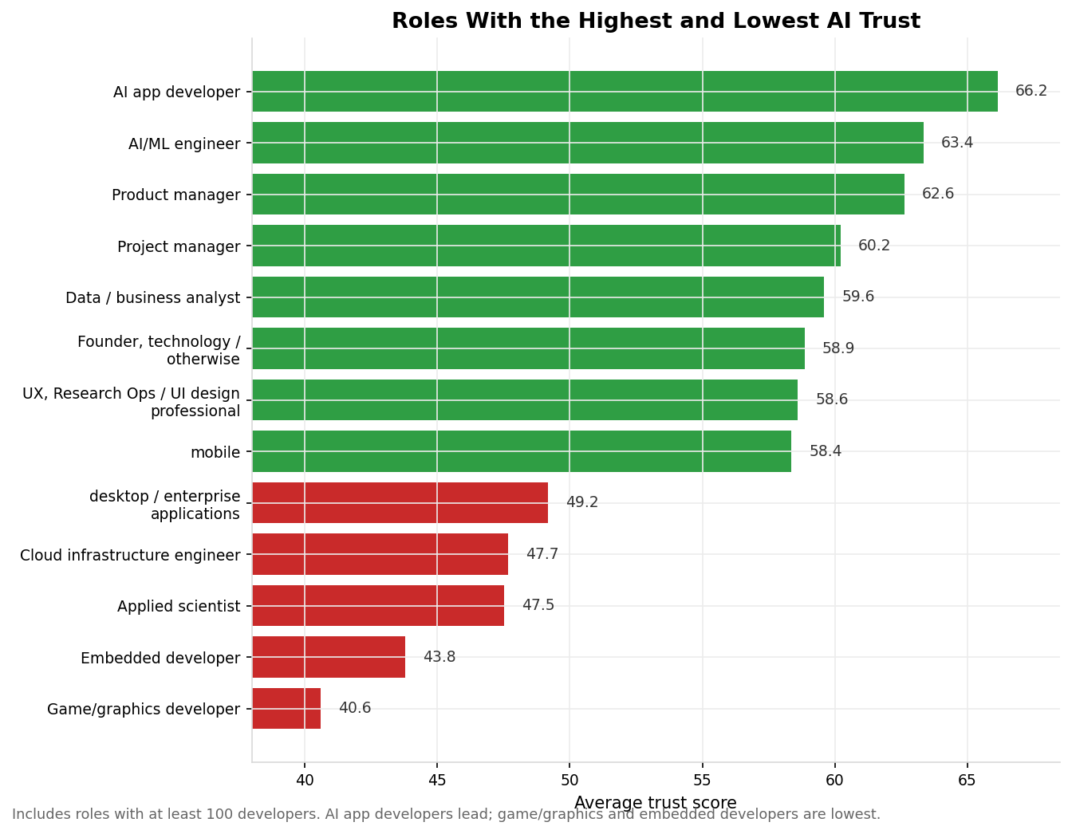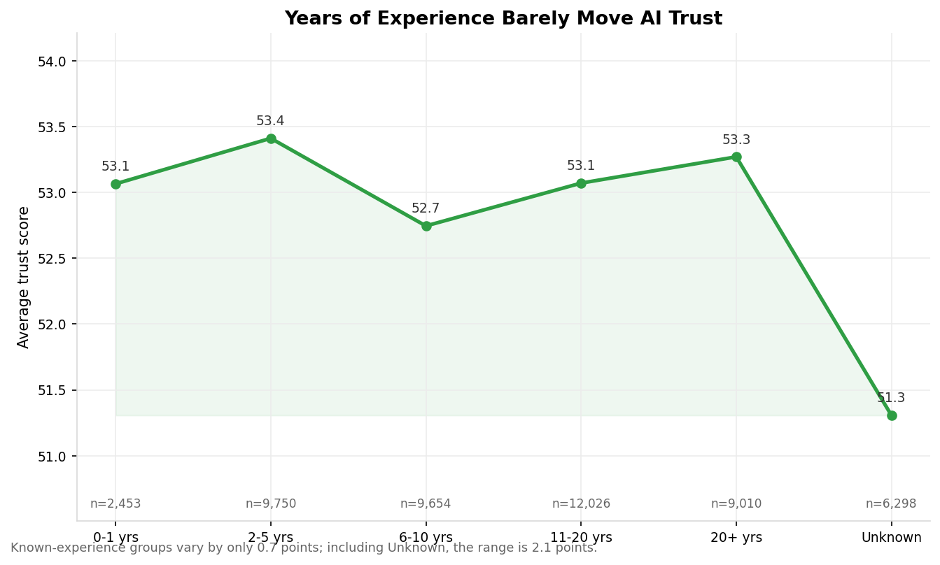
The most important analysis is the quadrant segmentation. We split all 27,258 developers (who answered all three trust questions) into four groups.
The largest group is High Usage - High Trust with 9,480 developers (35%) who use AI heavily and trust it. The second largest is Low Usage - Low Trust with 8,671 developers (32%) who neither use nor trust AI much. Then there is Low Usage - High Trust with 4,795 developers (18%) who are optimistic but haven't used AI much yet. And finally, the High Usage - Low Trust with 4,312 developers (16%). These are the paradox developers.
They use AI extensively but report the lowest trust and the highest frustration of all four groups. They use an average of 3.3 AI models and integrate AI into 3.2 workflow tasks.
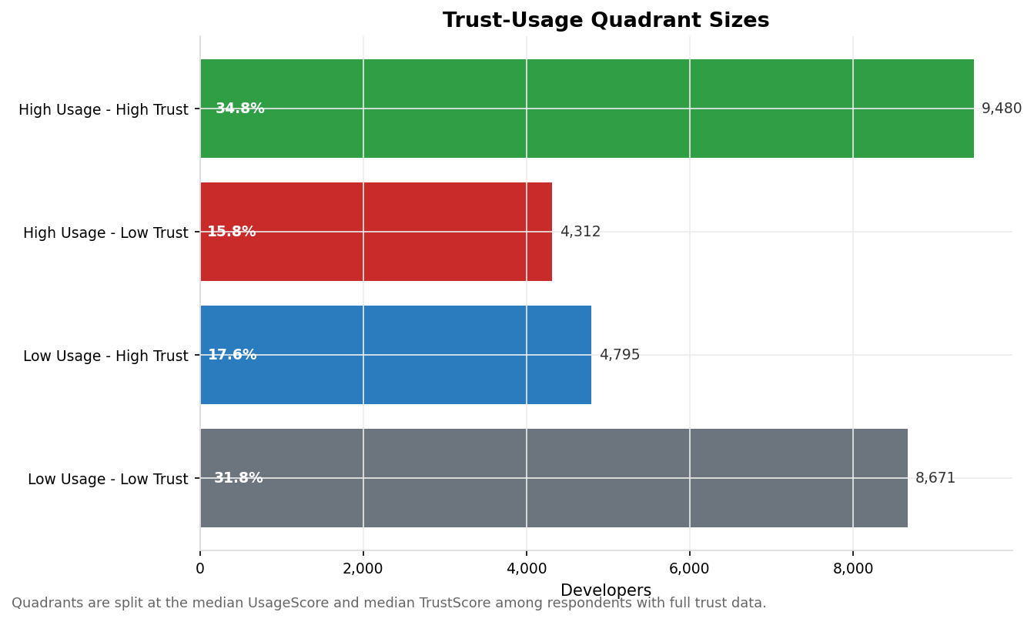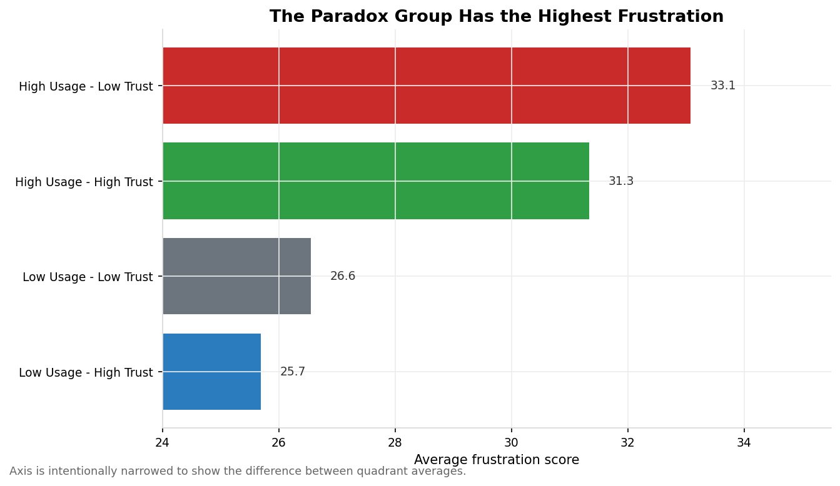
The scatter plot below shows every developer plotted by their usage and trust scores, with color representing frustration level.
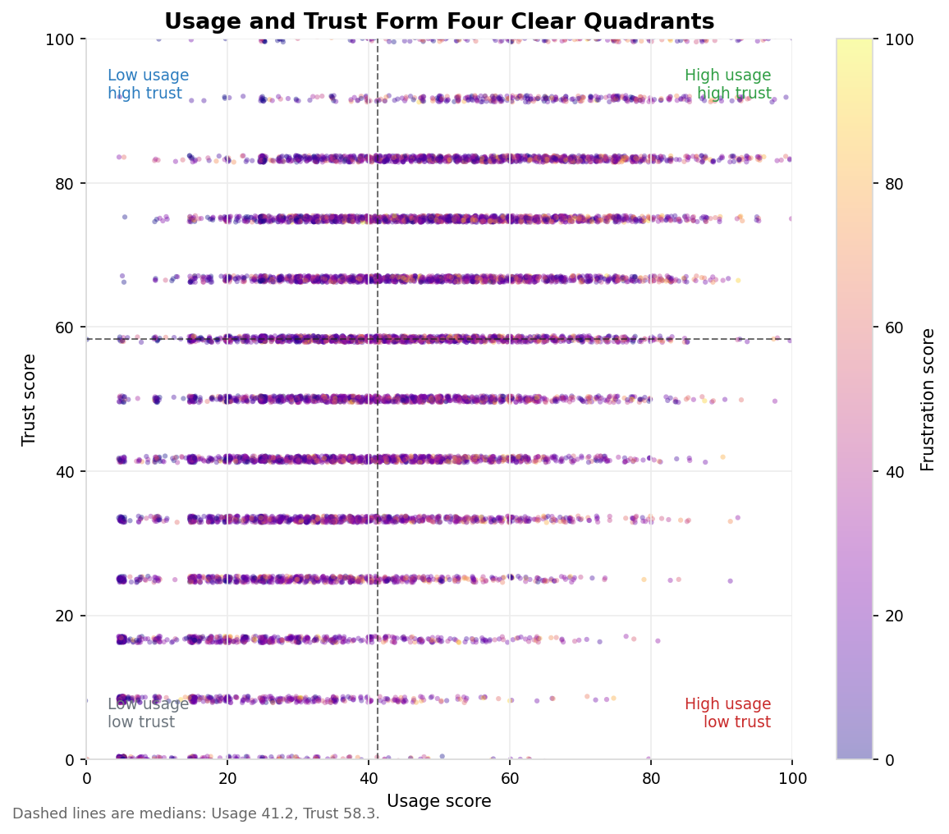

Machine Learning - Ray
K-Means Clustering: We used 11 features and ran K-Means for k=2 through k=6 as five parallel Ray tasks. We picked k=4 for the final model.
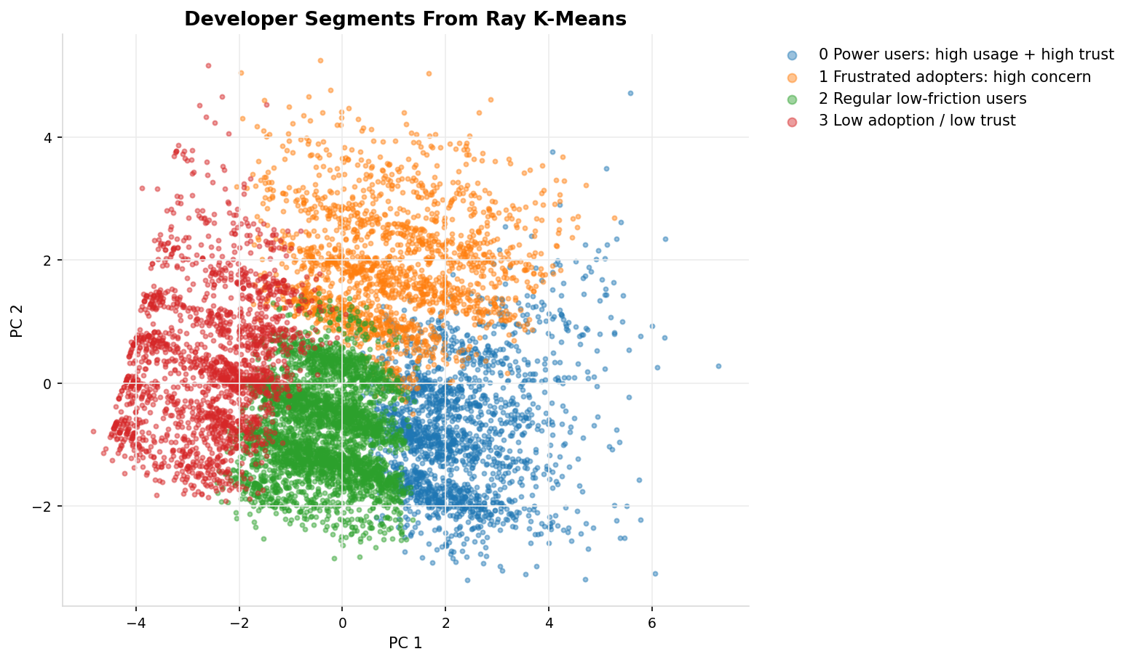
Random Forest: We trained a classifier to predict which developers belong to the paradox group. Accuracy was 83.6% on 5,063 test rows. The top predictors were:
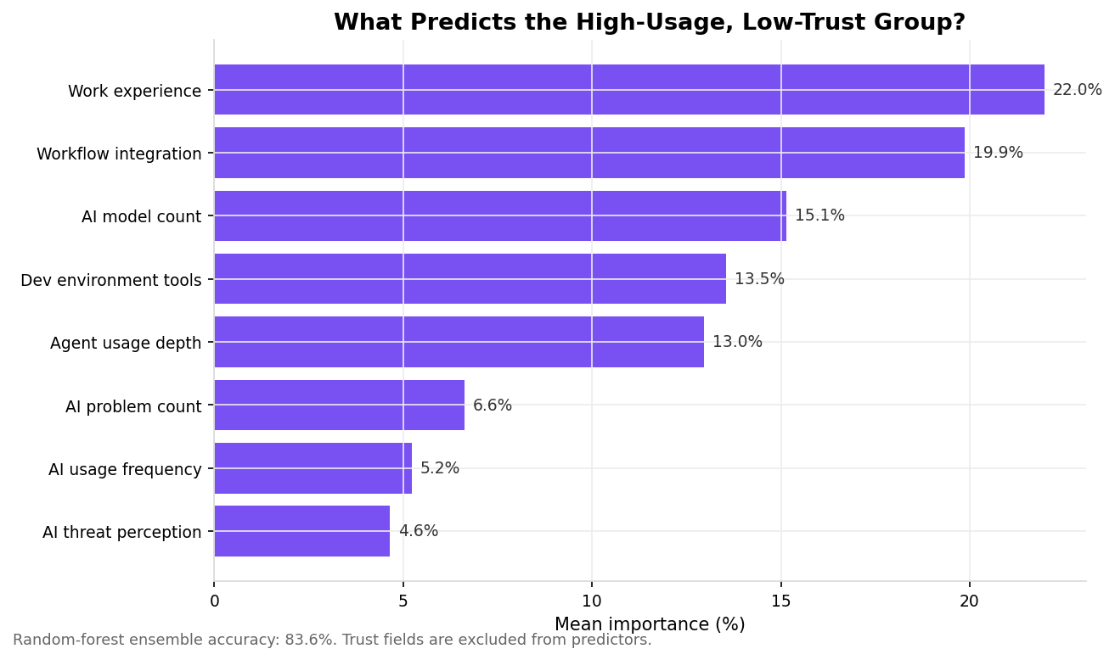
Frustration-related features (problem count, threat level) rank lowest. Paradox membership is predicted by how deeply someone integrates AI into their work and how experienced they are, not by how many complaints they have.

Dashboard
We built an interactive dashboard using Panel and Plotly that reads all pipeline outputs. It has sidebar filters for role, country and experience, six live KPI cards and three tabs covering the paradox analysis, trust dynamics and machine learning results. All charts update when filters change.
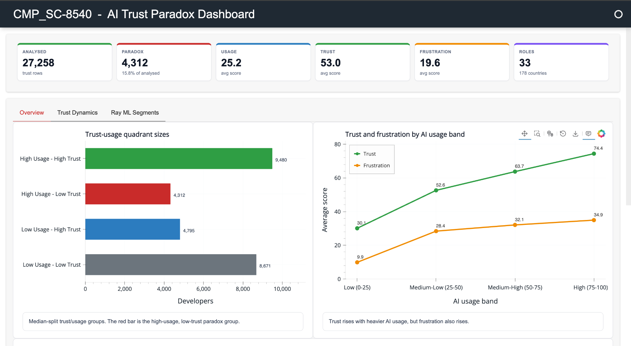
Testing
We ran five automated tests and all passed: row count is correct (49,191), all score columns exist, scores stay within 0-100, Spark SQL runs in under a second (0.356s) and all 16 output files were generated.
Conclusion
The AI Trust Paradox is real. 4,312 developers (16%) use AI tools heavily but don't trust the output. These are mostly experienced full-stack and back-end developers, not beginners. The Random Forest shows that what predicts paradox membership is professional experience and depth of AI integration-not frustration itself.

